ITEC 3450

Dr. Kairui Chen

**Assignment 01 – Processing Basics**

**Topics:** Processing

**Objectives:**

This assignment will help you become comfortable with the basics of Processing.

**Reminders:**

* Any evidence of sharing of code and/or other cheating will result in a 0 on this assignment for all involved parties. No make-ups will be allowed.
* If your program crashes, you will receive a 0 but will be allowed to make up the assignment for partial credit. Be sure you know how to debug your code!

**Resources:**

* The instructor
* Your fellow classmates
* Processing tutorials: https://processing.org/tutorials/.
* Processing API at: https://processing.org/reference/.
* The book Learning Processing, if you have it (optional).
* Google

**Instructions:**

* This assignment gives you three short problems to help you become comfortable with Processing and its API. You will NOT learn everything you need to know about Processing for this class. Instead, I will expect you to get into the habit of teaching yourself additional concepts as you need them.
* Because it is important to develop good coding habits, and because Processing is a Java -based language, I will ask you to observe proper Javadoc style. For this assignment, please include the following Javadoc comment at the top of each program:

/ **

* Short summary of what the program does

*

* @author Your name, first and last (preferred names are okay)

* @version Assign a version number (usually 1.0) and the date

*/

For example,

/ **

* Prints a message to the screen.

*

* @author Kairui Chen

* @version 1.0 8/21/2019

*/

* We will discuss comments for individual classes and methods in a later assignment.

1. Submit a Processing program that duplicates the picture:



canvasSize()

beginShape();

vertex(x, y);

vertex(…);

…

endShape(closePoint);

Notes:

* You should always define your own setup() and draw() functions.
* The canvas size is 500 x 500.
* The shape is centered in the image.
* If it were a square, it would have length 300.
* Please use, at minimum, the following functions:

beginShape(...)

endShape(...)

fill(...)

size(...)

vertex(...)

* Please use the following color:

(0, 255, 0, 255)

* When you’re done, please save your program out as LastnameFirstname_Asgt01_1.pde.

1. Submit a Processing program that duplicates the picture.

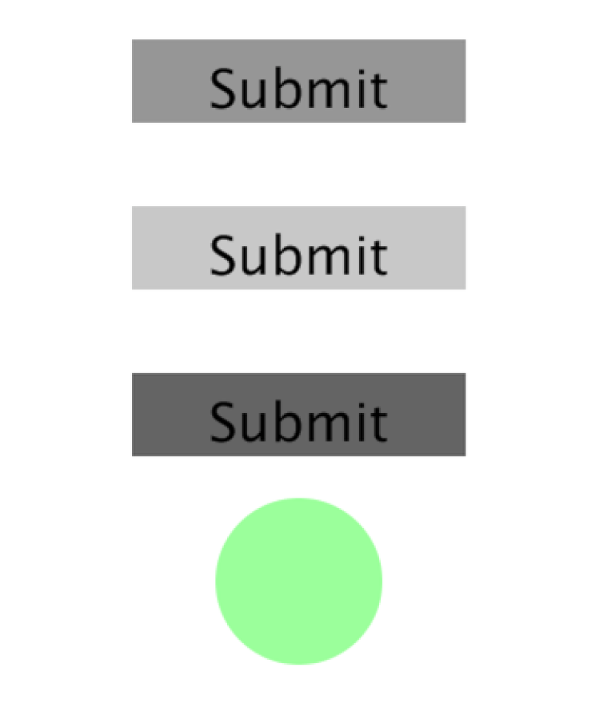

Notes:

* You should always define your own setup() and draw() functions.
* The canvas size is 500 x 500.
* Each shape has its center Y value at a multiple of 100 (i.e. 100, 200, 300, ...).
* The rectangles are 200x50.
* The circle has radius 50.
* The program uses the default font with font size 32.
* Please use, at minimum, the following functions:

background(...)

ellipse(...)

ellipseMode(...) – change to a mode OTHER than the default

fill(...)

noStroke(...)

rect(...)

rectMode(...) – change to a mode OTHER than the default

size(...)

text(...)

textAlign(...)

textSize(...)

* Please use the following colors:

(0)

(0, 255, 0, 100)

(100)

(150)

(200)

(255)

* When you’re done, please save your program out as LastnameFirstname_Asgt01_2.pde.

1. Submit a Processing program that draws a rectangle in the middle of the canvas. Every time the user clicks the rectangle, the background color behind the rectangle changes to a random color.



Notes:

* You should always define your own setup() and draw() functions.
* The canvas size is 500 x 500.
* The rectangle is centered and is 100x50.
* The background changes ONLY when the user clicks INSIDE the rectangle, not outside it.
* The background color changes ONLY once per click. Be sure the color DOES NOT change repeatedly if the user holds down the mouse button.
* The background should be ANY random RGB color. Remember that RGB has three components, each with a value 0 – 255.
* Please use, at minimum, the following functions

background(...)

fill(...)

if(...)

int(...)

mousePressed(...) – the function, NOT the variable

random(...)

rect(...)

rectMode(…)

size(…)

* Please use, at minimum, the following Processing variables:

mouseX

mouseY

* When you’re done, please save your program out as LastnameFirstname_Asgt01_3.pde

4. Submit all three pde files in a single .zip files on D2L: LastnameFirstname_Asgt01.zip